**8. GIS Data Acquisition**

**Geoportal**

A geoportal is a gateway to web-based geospatial [resources](https://enterprise.arcgis.com/en/inspire/10.8/get-started/introduction-to-geoportals.htm#ESRI_SECTION1_7F7C99A4A8784AC3A356813D346B1017), enabling you to discover, view, and access geospatial information and services made available by their providing organizations. Likewise, data providers can use the geoportal to make their geospatial resources discoverable, viewable, and accessible to others.

Esri Geoportal Server provides seamless communication with data services that use a wide range of communication protocols, and also supports searching, publishing, and managing standards-based resources.

**Esri Geoportal Server**

Esri Geoportal Server provides seamless communication with data services that use a wide range of communication protocols. It also supports searching, publishing, and managing standards-based metadata. Geoportal Server allows an organization to build a custom geoportal that meets INSPIRE Classic style, resource needs, and use objectives.

The INSPIRE Classic Geoportal Server system requirements are different from other software components of INSPIRE Classic. See the [installation and system requirements](https://github.com/Esri/geoportal-server/wiki/Installation) as well as the documentation for important information about Esri Geoportal Server.

The suite of software modules includes the following:

* A customizable Geoportal Server web app for publishing, administering, and searching resources
* A map interface for viewing live data resources
* Integration with content management systems (CMS) to organize resources to support focused user communities
* A separate Harvester component for harvesting a wide variety of metadata formats and protocols from many difference sources; search results are exposed through the REST API so resources can be easily shared among applications and users
* Widgets for searching geoportals from an HTML page with interactive maps

Esri Geoportal Server is maintained separately as a free and open source product on GitHub. The system requirements are different from other software components of ArcGIS for INSPIRE Classic. Refer to the [Esri Geoportal Server GitHub page](https://github.com/Esri/geoportal-server-catalog) for detailed system requirements and installation instructions for Geoportal Server Catalog and Geoportal Server Harvester.

# **The USGS (United States Geological Survey)**

The [USGS](https://www.usgs.gov/) (United States Geological Survey) is a science bureau within the [United States Department of the Interior](https://www.doi.gov/). The USGS provides science about the natural hazards that threaten lives and livelihoods; the water, energy, minerals, and other natural resources we rely on; the health of our ecosystems and environment; and the impacts of climate and land-use change. Our scientists develop new methods and tools to enable timely, relevant, and useful information about the Earth and its processes.

# **USGS Earth Explorer**

The USGS Earth Explorer data portal is your one stop shop for obtaining geo-spatial datasets from our extensive collections. Users can navigate via interactive map or text search to obtain Landsat satellite imagery, Radar data, UAS data, digital line graphs, digital elevation model data, aerial photos, Sentinel satellite data, some commercial satellite imagery including IKONOS and OrbView3, land cover data, digital map data from the National Map, Remote sensing, satellite imagery, Landsat, digital elevation models, DEM, digital maps, radar, UAS imagery, aerial photography, AVHRR data, commercial satellite imagery, and many other datasets. Users can search by exact location via the interactive map or input specific coordinates to view what data types are available.

# **DEM data**

A Digital Elevation Model (DEM) is a representation of the bare ground (bare earth) topographic surface of the Earth excluding trees, buildings, and any other surface objects. DEMs are created from a variety of sources. USGS DEMs used to be derived primarily from [topographic maps](https://www.usgs.gov/programs/national-geospatial-program/topographic-maps).

Those are being systematically replaced with DEMs derived from high-resolution [Lidar](https://www.usgs.gov/faqs/what-lidar-data-and-where-can-i-download-it?qt-news_science_products=0#qt-news_science_products) and [IfSAR](https://www.usgs.gov/centers/eros/science/usgs-eros-archive-radar-ifsar-orthorectified-radar-image-ori-alaska?qt-science_center_objects=0" \l "qt-science_center_objects) (Alaska only) data.

# **Difference between Lidar data and a digital elevation model (DEM)**

Light detection and ranging [(Lidar](https://www.usgs.gov/news/earthword-lidar)) data are collected from aircraft using sensors that detect the reflections of a pulsed laser beam. The reflections are recorded as millions of individual points, collectively called a “point cloud,” that represent the 3D positions of objects on the surface including buildings, vegetation, and the ground.

Digital elevation models ([DEMs](https://www.usgs.gov/faqs/what-a-digital-elevation-model-dem?qt-news_science_products=0#qt-news_science_products)) are one of many products that can be derived from lidar data, though they can also be derived from other sources. DEMs are digital representations of the earth’s topographic surface. They’re a “bare-earth” product because they do not include surface features like buildings and vegetation.

A high-resolution DEM can be derived from lidar point-cloud data by stripping away the surface features and sampling the ground elevation in uniform increments to produce a bare earth model.

# **3D Elevation Program (3DEP) DEMs**

The USGS 3D Elevation Program (3DEP) is in the process of collecting high-quality [lidar](https://www.usgs.gov/news/earthword-lidar) and [If SAR](https://www.usgs.gov/core-science-systems/ngp/user-engagement-office/alaska-mapping-initiative) (for Alaska) coverage for all of the United States and its territories. As this new data becomes available, legacy Digital Elevation Models (DEMs) are being systematically replaced with high-resolution DEMs produced almost entirely from the lidar and ifsar data.

Legacy DEMs were produced from sources that include older Lidar technology, cartographic contours derived from hand-drawn topographic maps, and [Shuttle Radar Topography Mission](https://www.usgs.gov/centers/eros/science/usgs-eros-archive-digital-elevation-shuttle-radar-topography-mission-srtm-non?qt-science_center_objects=0#qt-science_center_objects) (SRTM) elevation data.

# **Vertical accuracy of the 3D Elevation Program (3DEP) DEMs**

As of 2022, the absolute vertical accuracy of the 3D Elevation Program (3DEP) 1/3 arc-second seamless DEM product within the conterminous United States is approximately 0.82 meters root mean square error (RMSE), based on a comparison to almost 25,000 NOAA National Geodetic Survey [OPUS points](https://geodesy.noaa.gov/OPUS/about.jsp).  Accuracy has improved from a RMSE of 1.55 meters tested in 2013, due to the addition of lidar projects over the years.

The vertical accuracy of the 3DEP [dynamic elevation service](https://apps.nationalmap.gov/services/), which is a web coverage service (WCS) that includes multiple resolutions of DEMs (including 1-m resolution lidar-based DEMs where available), currently has a RMSE of 0.53 meters.

It is important to note that the vertical accuracy actually varies significantly across the U.S. because of differences in source quality, terrain relief, land cover, and other factors.

### **Spatial Resolution**

DEM data are used in flood models to represent a physical land-surface. The spatial resolution of a DEM refers to the area of land being represented by a single grid cell. So, a spatial resolution of 10 metres means one grid cell is representing a 10 x 10 metre area of physical land. Low (or coarse) resolution and high (or fine) resolution are relative terms. ‘Higher’ resolution implies comparatively greater preservation of land features, while a ‘lower’ resolution dataset generally smooths over topographic details (Environmental Systems Research Institute, Inc., 2016).  
  
DEM resolutions used in the hydrological and hydraulic modelling industry typically range from 1000m to 2m or less (Vaze, Teng, & Spencer, 2010). Here, we limit our discussion to the resolution of JBA’s national-scale flood maps, which range from 30m- 5m.

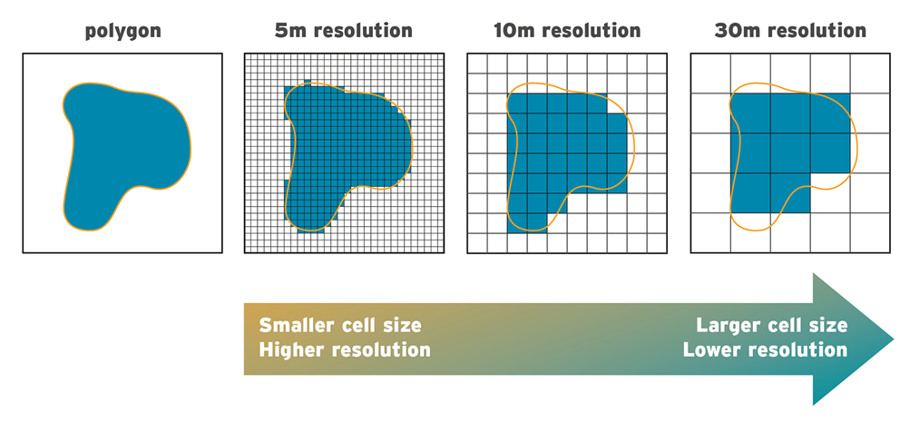  
***Figure 1:****Example of higher (left) to lower (right) spatial resolution representing the same land area polygon.*

### **THE SPATIAL RESOLUTION TRADE-OFF**

Flood modellers face plenty of important decisions throughout the flood modelling process. We study complex natural processes and investigate the assumptions used to represent them; we source, vet and assimilate input data; we design and test models and critically analyse the results. Central to this applied and uncertain science is the DEM. Good quality DEM data are important because we use these to estimate how water interacts with the environment and identify where flooding is most likely to pose challenges to people and properties. The accuracy of water depth predictions is linked to the accuracy and spatial resolution of the DEM (Vaze, Teng, & Spencer, 2010).

Yet, although higher spatial resolution and accuracy often translate to improved results, these benefits cannot be considered in isolation, especially when we consider how numerical flood models work. Numerical models rely on multiple simulations to represent the physical processes of flooding and these simulations can number into the hundreds of thousands or more depending on an area’s extent. The more complex models are (i.e., the higher the spatial resolution), the greater the demands on computational power, processing time, file size, data storage and cost (Environmental Systems Research Institute, Inc., 2016). On the other hand, using comparatively lower resolution data means lower feature spatial accuracy but faster processing and smaller file sizes. Thus, depending on a client's objectives and requirements, lower resolution may fit the bill.

### **THE BENEFITS OF 30M RESOLUTION**

These trade-offs highlight the advantages that lower resolution data can offer. Consider this analogy: in a standard health check-up, most people accept insightful, albeit generalised, information about their health, such as heart rate, blood pressure and joint reactivity. In a short amount of time, key information is summarised. However, if the results triggered an alarm regarding a person’s blood pressure, reasonably he would seek out more detailed, timely and costly – i.e., better resolution- analyses for that specific health concern.

In the same way, flood modellers seek to use the level of complexity reasonable for the task at hand. JBA’s suite of flood maps includes global national-scale maps at 30m resolution. These national-scale flood maps enable users to compare flood data at different locations across countries or continents for a consistent view of river, surface water, and in some regions, coastal flooding. They can be used to indicate areas that may benefit from a more detailed flood risk assessment based on higher resolution data, guiding high-level decision making and balancing the requirements of the task at hand with the complexities mentioned above.

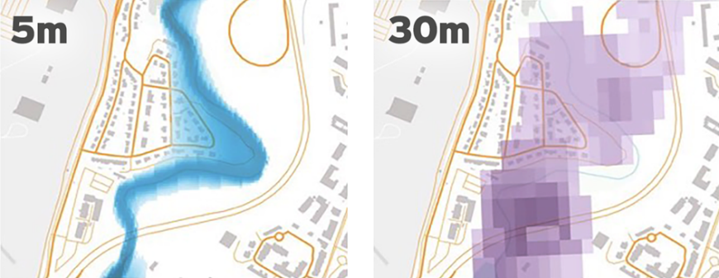  
***Figure 2:*** Higher resolution data (left) define flow paths of water better. Lower resolution data (right) help highlight flood susceptible areas that may benefit from further analysis.

### **THE BENEFITS OF HIGHER RESOLUTION**

The higher the DEM resolution, the greater the preservation of the topographical terrain features. This provides better definition of the floodplain, small streams, roads and other narrow conduits of flow which can significantly impact results. While the availability of high-resolution terrain data is on the rise, it’s still not available everywhere. Often these data are limited to countries and regions with high concentrations of population and/or economic development. However, where there is a client and market need for higher resolution flood data and good quality and quantity of data, it is appropriate to invest in these.

JBA provides high-resolution [flood maps](https://www.jbarisk.com/products-services/maps-and-analytics/) for the UK and Republic of Ireland, Continental Europe and the US at 5m resolution. Figure 3 illustrates the impact using higher resolution data has had on flood maps for downtown Miami. Although both images indicate the general areas at risk from flooding, the 5m map captures movement of water in complex urban areas which is not captured in the 30m map. The validation of our modelling outputs with information about historical and current flood events confirms an improved, more detailed view of flooding from high-resolution maps.

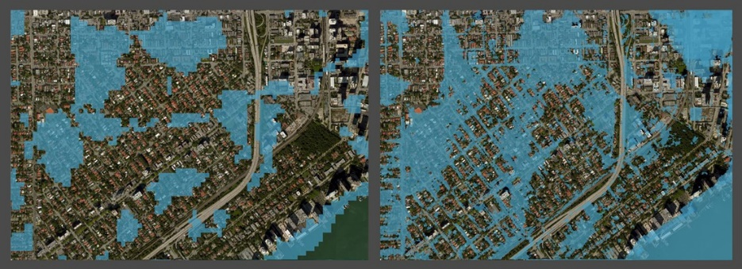  
***Figure 3:****JBA 30m flood map (left) vs JBA 5m flood map (right) for downtown Miami, where flooding in narrow walkways is more realistically represented in the 5m map.*

### **ACHIEVING THE RIGHT BALANCE**

Modelling flood is a complex science and it's the combination of a variety of factors that enable us to meet the different requirements of clients. [While resolution is not the only metric for determining the quality of a dataset](https://www.jbarisk.com/news-blogs/what-makes-good-elevation-data-for-national-scale-flood-mapping/), in geographical areas where we are confident in the quality and quantity of the input data, using higher resolution resources has made an important difference to assessing flood risk.

Ultimately, the most informed decisions can be made by those who have access to the right expertise. [Speak to us](https://www.jbarisk.com/get-in-touch/) about the range of data we provide, how it can be used, bespoke [consultancy](https://www.jbarisk.com/products-services/consultancy/) options we offer and identifying the best option for you.

**Data contained in the USGS DLD files**

Digital Line Graphs (DLGs) are digital vector representations of cartographic information derived from USGS maps and related sources.

**Large-Scale (7.5-minute)** DLGs correspond to the USGS 1:20,000-, 1:24,000-, and 1:25,000-scale topographic quadrangle maps. They are primarily cast to the Universal Transverse Mercator (UTM) projection system, but some are cast to the State Plane coordinate system. They are referenced to either the North American Datum (NAD) of 1927 (NAD27) or the NAD of 1983 (NAD83).

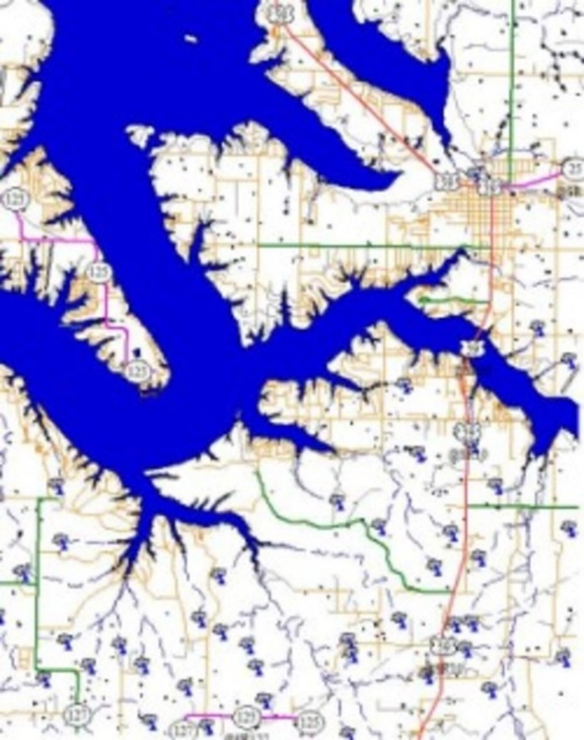

Digital Line Graph (DLG) - Large Scale (7.5 min) - Hydrography and Tranportation layers - Grove Quad – Oklahoma (Public domain)

Depending on scale, the following layers (or categories of feature type) are available:

|  |  |
| --- | --- |
| **Layer** | **Feature Type** |
| Public Land Survey System (PLSS) | Township, range, and section lines |
| Boundaries (BD) | State, county, city, and other national and State lands such as forests and parks |
| Transportation (TR) | Roads and trails, railroads, pipelines, and transmission lines |
| Hydrography (HY) | Flowing water, standing water, and wetlands |
| Hypsography (HP) | Contours and supplementary spot elevations |
| Non-vegetative features (NV) | Glacial moraine, lava, sand, and gravel |
| Survey control and markers (SM) | Horizontal and vertical monuments (third order or better) |
| Man-made features (MS) | Cultural features, such as buildings, not collected in other data categories |
| Vegetative surface cover (SC) | Woods, scrub, orchards, and vineyards |

**SSURGO**

The Soil Survey Geographic Database (SSURGO) contains information about soil as collected by the National Cooperative Soil Survey over the course of a century. The information was gathered by walking over the land and observing the soil. Many soil samples were analyzed in laboratories.

### **Description of SSURGO Database**

The SSURGO database contains information about soil as collected by the National Cooperative Soil Survey over the course of a century. The information can be displayed in tables or as maps and is available for most areas in the United States and the Territories, Commonwealths, and Island Nations served by the USDA-NRCS. The information was gathered by walking over the land and observing the soil. Many soil samples were analyzed in laboratories. The maps outline areas called map units. The map units describe soils and other components that have unique properties, interpretations, and productivity. The information was collected at scales ranging from 1:12,000 to 1:63,360. More details were gathered at a scale of 1:12,000 than at a scale of 1:63,360. The mapping is intended for natural resource planning and management by landowners, townships, and counties. Some knowledge of soils data and map scale is necessary to avoid misunderstandings.

The maps are linked in the database to information about the component soils and their properties for each map unit. Each map unit may contain one to three major components and some minor components. The map units are typically named for the major components. Examples of information available from the database include available water capacity, soil reaction, electrical conductivity, and frequency of flooding; yields for cropland, woodland, rangeland, and pastureland; and limitations affecting recreational development, building site development, and other engineering uses.

SSURGO datasets consist of map data, tabular data, and information about how the maps and tables were created. The extent of a SSURGO dataset is a soil survey area, which may consist of a single county, multiple counties, or parts of multiple counties. SSURGO map data can be viewed in the Web Soil Survey or downloaded in ESRI® Shapefile format. The coordinate systems are Geographic. Attribute data can be downloaded in text format that can be imported into a Microsoft® Access® database.

**COGO**

Coordinate geometry (COGO) is used to map the location of features and their boundaries measured on the ground and recorded on survey plans, deed descriptions, and other types of physical or electronic land record documents.

COGO measurements typically describe features relative to each other. The following example survey plan shows COGO measurements for a road centerline and parcel boundaries adjoining the road.

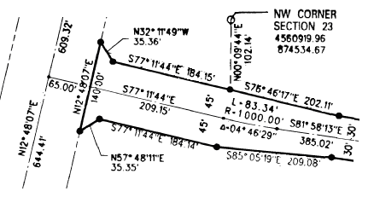

An example survey plan shows COGO descriptions for a road centerline and parcel boundaries adjoining the road.

Survey plans can include references to points with known coordinates that spatially locate or georeference COGO features within a coordinate system. These points are known as control points, monuments, or cadastral reference points.

## COGO features

In ArcGIS Pro, COGO descriptions comprise a set of measurements that define a line feature.

* Straight lines are described with a direction and a distance.
* Curved lines include a radius, angle, arc length, and chord direction.
* Spirals are described with two radii. The second radius can be set to infinity.

[Enabling COGO for a line feature class](https://pro.arcgis.com/en/pro-app/3.1/help/editing/enable-cogo-for-a-line-feature-class.htm) adds COGO attribute fields and COGO-enabled labeling to the feature class. COGO fields are used to store survey measurements typed into [COGO-aware editing tools](https://pro.arcgis.com/en/pro-app/3.1/help/editing/cogo-and-ground-to-grid-tools-for-editing.htm).

In addition to COGO-enabled line features, you can use simple point, line, and polygon features to represent COGO features described below.

* Points can represent the endpoints of measured lines and curves. Points can also represent surveyed points and have known x, y, z coordinates. You can use a simple point feature class with x, y, z attributes to represent these points, or use a parcel fabric to manage parcel points.
* Lines can represent measured distances and directions. Measured lines can also represent circular arcs and spiral curves. You can use a simple line feature class or manage parcel lines in a parcel fabric. Examples of common tools that create COGO lines include the Two-Point line tool, the Circular Arc tool, and the Traverse tool.
* Polygons can represent parcel areas enclosed by COGO lines. You can use a simple polygon feature class or manage parcel polygons in a parcel fabric. Polygon features can be created with the Construct Polygon tool by starting from selected COGO lines. Polygons can also be created using the Traverse tool.

**Questions**

# What is a digital elevation model (DEM)? 2-3

# What does the USGS (United States Geological Survey) do? 2-3

# What is the difference between Lidar data and a digital elevation model (DEM)? 4

# What data sources are used to produce the 3D Elevation Program (3DEP) DEMs? 3

# What is the vertical accuracy of the 3D Elevation Program (3DEP) DEMs? 3

1. What kinds of data are contained in the USGS DLD files? 4-5
2. Explain SSURGO and COGO? With their features. 3-4
3. Make a list of tables (layers or categories of feature type) depending on scale. 2-3